Lab # 12

Packages

OBJECTive:
An apparent detour to understand what is package is in Java.

THEORY:

12.1 UNDERSTANDING PACKAGES
Packages are implicit in the organization of the standard classes as well as your own programs, and they influence the names you can use for classes and the variables and methods they contain. Essentially, a package is a uniquely named collection of classes. The primary reason for grouping classes in packages is to avoid possible name clashes with your own classes when you are using prewritten classes in an application. The names used for classes in one package will not interfere with the names of classes in another package or your program because the class names in a package are all qualified by the package name.
Thus, the String class you have been using is in the java.lang package, so the full name of the class is java.lang.String. You have been able to use the unqualified name because all the classes in the java.lang package are always available in your program code; there’s an implicit import statement in effect for all the names in the java.lang package. If you happened to have defined a class of your own with the name String, using the name String would refer to your class, but you could still use the library class that has the same name by using its full name in your code, java.lang.String.

Every class in Java is contained in a package, including all those you have defined in the examples. You haven’t seen many references to package names so far because you have been implicitly using the default package to hold your classes, and this doesn’t have a name.

Packaging Up Your Classes:
Putting one of your classes in a named package is very simple. You just add a package statement as the first statement in the source file containing the class definition. Note that it must always be the first statement. Only comments or blank lines are allowed to precede the package statement. A package statement consists of the keyword package followed by the package name and is terminated by a semicolon. If you want the classes in a package to be accessible outside the package, you must declare the class using the keyword public in the first line of your class definition. Class definitions that aren’t preceded by the keyword public are accessible only from methods in classes that belong to the same package.
For example, to include the Sphere class in a package called Geometry, the contents of the file Sphere.java would need to be:
package Geometry;
public class Sphere { // Details of the class definition
}
Each class that you want to include in the package Geometry must contain the same package statement at the beginning, and you must save all the files for the classes in the package in a directory with the same name as the package, that is, Geometry. Note the use of the public keyword in the definition of the Sphere class. This makes the class accessible generally. If you omit the public keyword from the class definition, the class would be accessible only from methods in classes that are in the Geometry package.
Note that you would also need to declare the constructors and methods in the class as public if you want them to be accessible from outside of the package.

Adding a class to a Package:
We can add more classes to an created package by using package name at the top of the program and saving it in the package directory. We need a new java file to define a public class, otherwise we can add the new class to an existing .java file and recompile it.

Subpackages:
Packages that are inside another package are the subpackages. These are not imported by default, they have to imported explicitly. Also, members of a subpackage have no access privileges, i.e., they are considered as different package for protected and default access specifiers.
Example :
import java.util.*;
util is a subpackage created inside java package.

Packages and the Directory Structure:
Packages are actually a little more complicated than they appear at first sight, because a package is intimately related to the directory structure in which it is stored. You already know that the definition of a class with the name ClassName must be stored in a file with the name ClassName.java, and that all the files for classes within a package PackageName must be included in a directory with the name PackageName. You can compile the source for a class within a package and have the .class file that is generated stored in a different directory, but the directory name must still be the same as the package name.
As you are aware from the existence of the java.lang package that contains the String class, a package can have a composite name that is a combination of two or more simple names. You can specify a package name as any sequence of names separated by periods. For example, you might have developed several collections of classes dealing with geometry, perhaps one that works with 2D shapes and another with 3D shapes. In this case you might include the class Sphere in a package with the statement:
package Geometry.Shapes3D;
and the class for circles in a package using the statement:
package Geometry.Shapes2D;
Defining Classes In this situation, the files containing the classes in the Geometry.Shapes3D packages are expected to be in the directory Shapes3D and the files containing the classes in the Geometry.Shapes2D packages are expected to be in the directory Shapes2D. Both of these directories must be subdirectories of a directory with the name Geometry. In general, you can have as many names as you like separated by periods to identify a package, but the package name must reflect the directory structure in which the package is stored. This is illustrated in Figure.
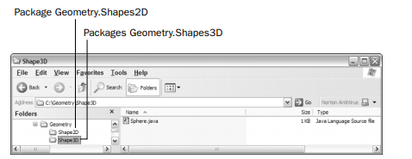

Packages work:
Package names and directory structure are closely related. For example if a package name is college.staff.cse, then there are three directories, college,
staff and cse such that cse is present in staff and staff is present in college. Also, the directory college is accessible through CLASSPATH variable, i.e., path of parent directory of college is present in CLASSPATH. The idea is to make sure that classes are easy to locate.

Accessing classes inside a package:
Consider following two statements:
// import the Vector class from util package.
import java.util.vector;

// import all the classes from util package
import java.util.*;
- First Statement is used to import Vector class from util package which is contained inside java.
- Second statement imports all the classes from util package.
// All the classes and interfaces of this package
// will be accessible but not subpackages.
import package.*;

// Only mentioned class of this package will be accessible.
import package.classname;

// Class name is generally used when two packages have same
// class name. For example in below code both packages have
// date class so using fully qualified name to avoid conflict
import java.util.Date;
import my.packag.Date;

// Java program to demonstrate accessing of members when
// a corresponding classes are imported and not imported.
import java.util.Vector;

public class ImportDemo
{
public ImportDemo()
{
// java.util.Vector is imported, hence we are
// able to access directly in our code.
Vector newVector = new Vector();

// java.util.ArrayList is not imported, hence
// we were referring to it using the complete
// package.
java.util.ArrayList newList = new java.util.ArrayList();
}

public static void main(String arg[])
{
new ImportDemo();
}
}

Types of Packages:
Built-in Packages:
These packages consist of a large number of classes which are a part of Java. Some of the commonly used built-in packages are:
1) java.lang: Contains language support classes(e.g classed which defines primitive data types, math operations). This package is automatically imported.
2) java.io: Contains classed for supporting input / output operations.
3) java.util: Contains utility classes which implement data structures like Linked List, Dictionary and support ; for Date / Time operations.
4) java.applet: Contains classes for creating Applets.
5) java.awt: Contain classes for implementing the components for graphical user interfaces (like button , ;menus etc).
6) java.net: Contain classes for supporting networking operations.

User-defined packages:
These are the packages that are defined by the user. First we create a directory myPackage (name should be same as the name of the package). Then create the MyClass inside the directory with the first statement being
the package names.

// Name of the package must be same as the directory
// under which this file is saved
package myPackage;

public class MyClass
{
public void getNames(String s)
{
System.out.println(s);
}
}

Now we can use the MyClass class in our program.

/* import 'MyClass' class from 'names' myPackage */
import myPackage.MyClass;

public class PrintName
{
public static void main(String args[])
{
// Initializing the String variable
// with a value
String name = "GeeksforGeeks";

// Creating an instance of class MyClass in
// the package.
MyClass obj = new MyClass();

obj.getNames(name);
}
}
Note: MyClass.java must be saved inside the myPackage directory since it is a part of the package.

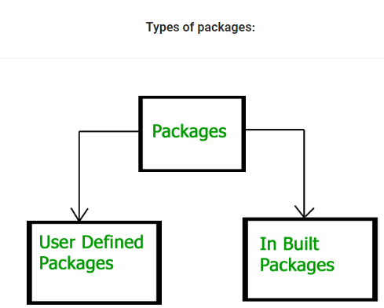

LAB TASK

1. Create a package name bank_account, containing two classes named as Calculate_interest for customers and Calculate_special_Interest for employees respectively. Each class should carry a method of calculating the amount.

Formulae:
interestAmount = amount * rate/100;
special_interestAmount = (amount * rate/100) + 100;

2. Import the bank_account package in to a class name Calculation_record and display the calculated amount of interest given to the customer and the employees respectively.

